**Assignment 3 : Retrieve data using Group By clause**

**Sample table1:Department**

-dept_id

-dept_name

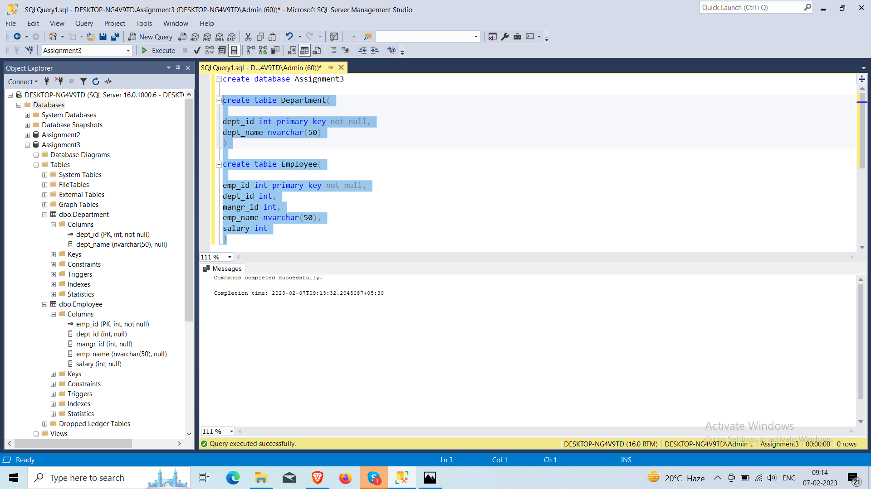

**Sample table2: Employee**

-emp_id

-dept_id

-mngr_id

-emp_name

-salary



**Insert data in table**

* **Table Department**

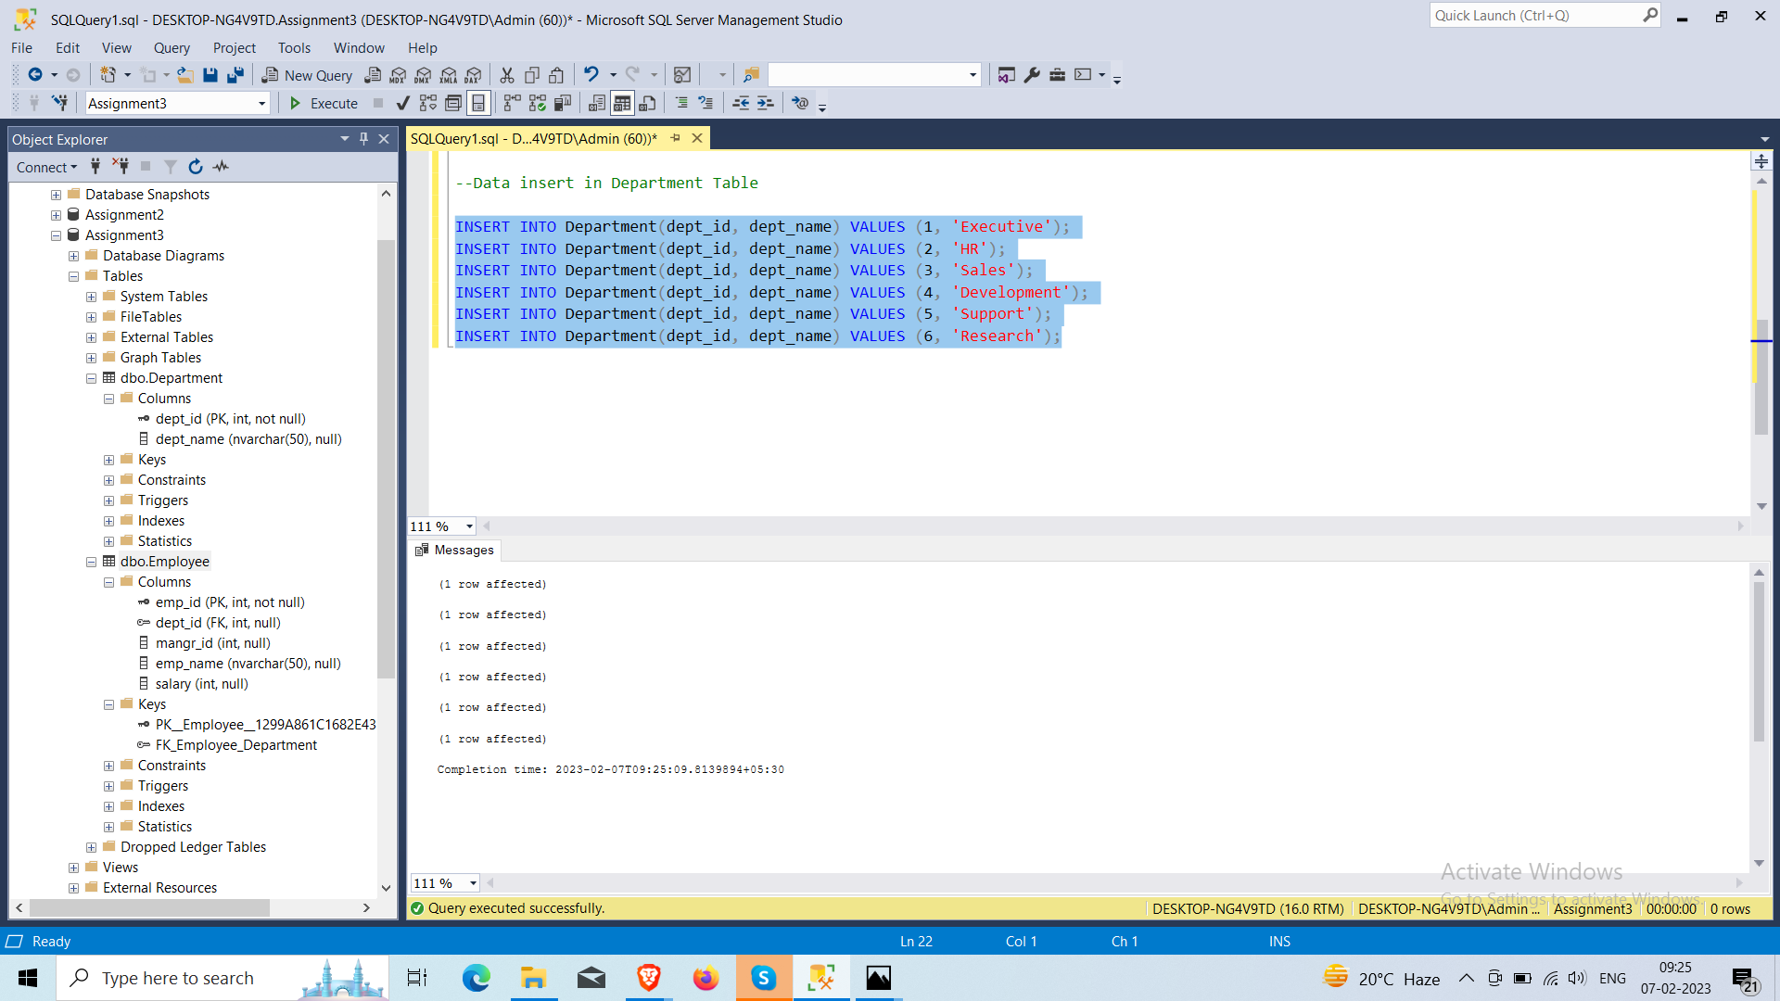

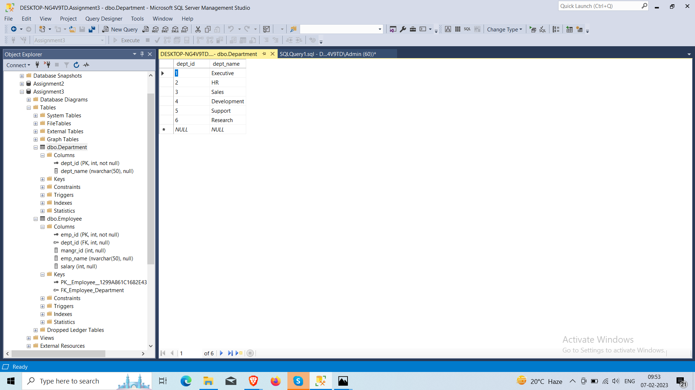

* **Table Emploay**

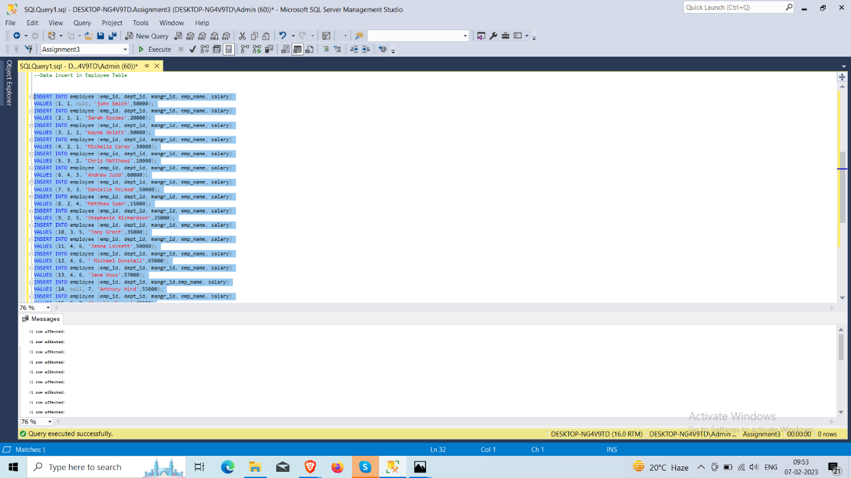

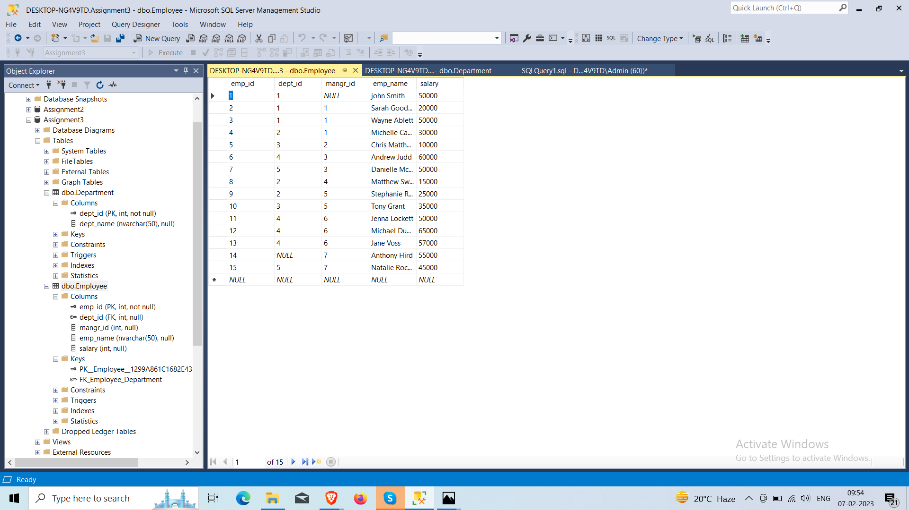

1. **write a SQL query to find Employees who have the biggest salary in their Department**

select Department.dept_name as Department, Employee.emp_name as Employee,Employee.salary

from Department join Employee

on Employee.dept_id= Department.dept_id

join(

select max(salary)as salary, dept_id from Employee

group by dept_id) as mx

on Employee.salary=mx.salary and Employee.dept_id=mx.dept_id

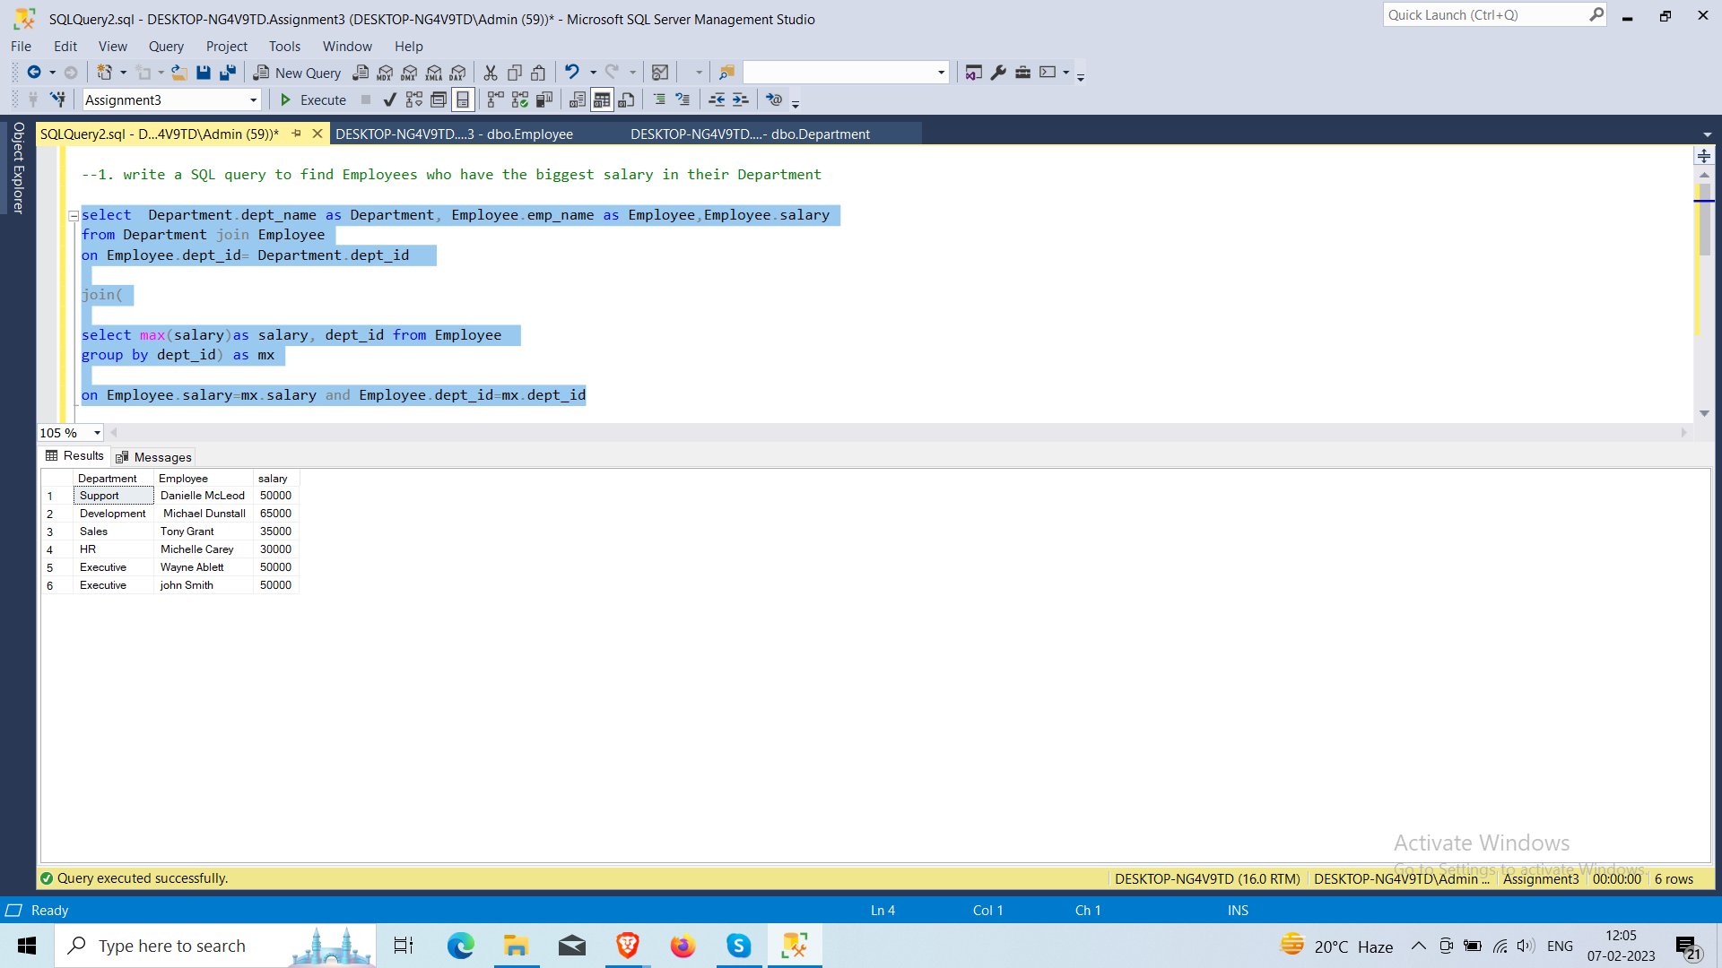

1. **write a SQL query to find Departments that have less than 3 people in it**

select Department.dept_id, Department.dept_name,COUNT(Employee.dept_id) as [Total members]

from Employee

right join Department

on Employee.dept_id=Department.dept_id

group by Department.dept_id,dept_name

having COUNT(Employee.dept_id) < 3

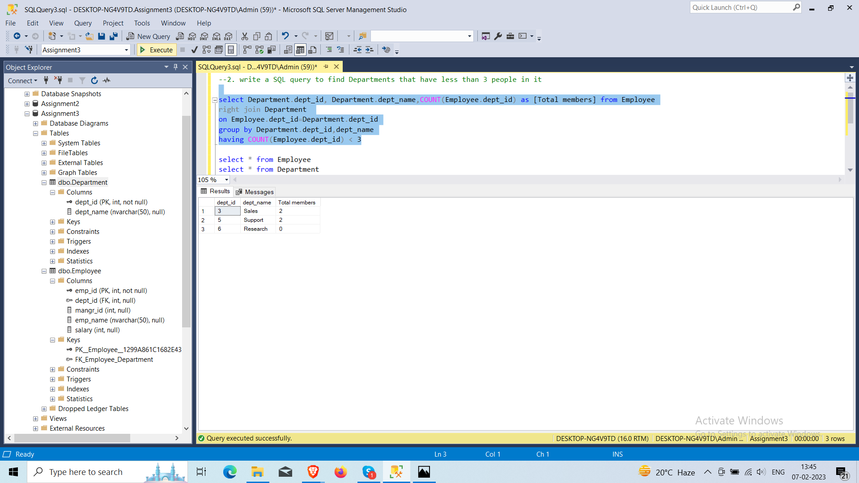

1. **write a SQL query to find All Department along with the number of people there**

select Department.dept_id as 'Depatement ID' , dept_name as [Department Name], count(Employee.emp_name) as 'Total members'

from department

left join employee on Department.dept_id = Employee.dept_id

group by Department.dept_id, dept_name

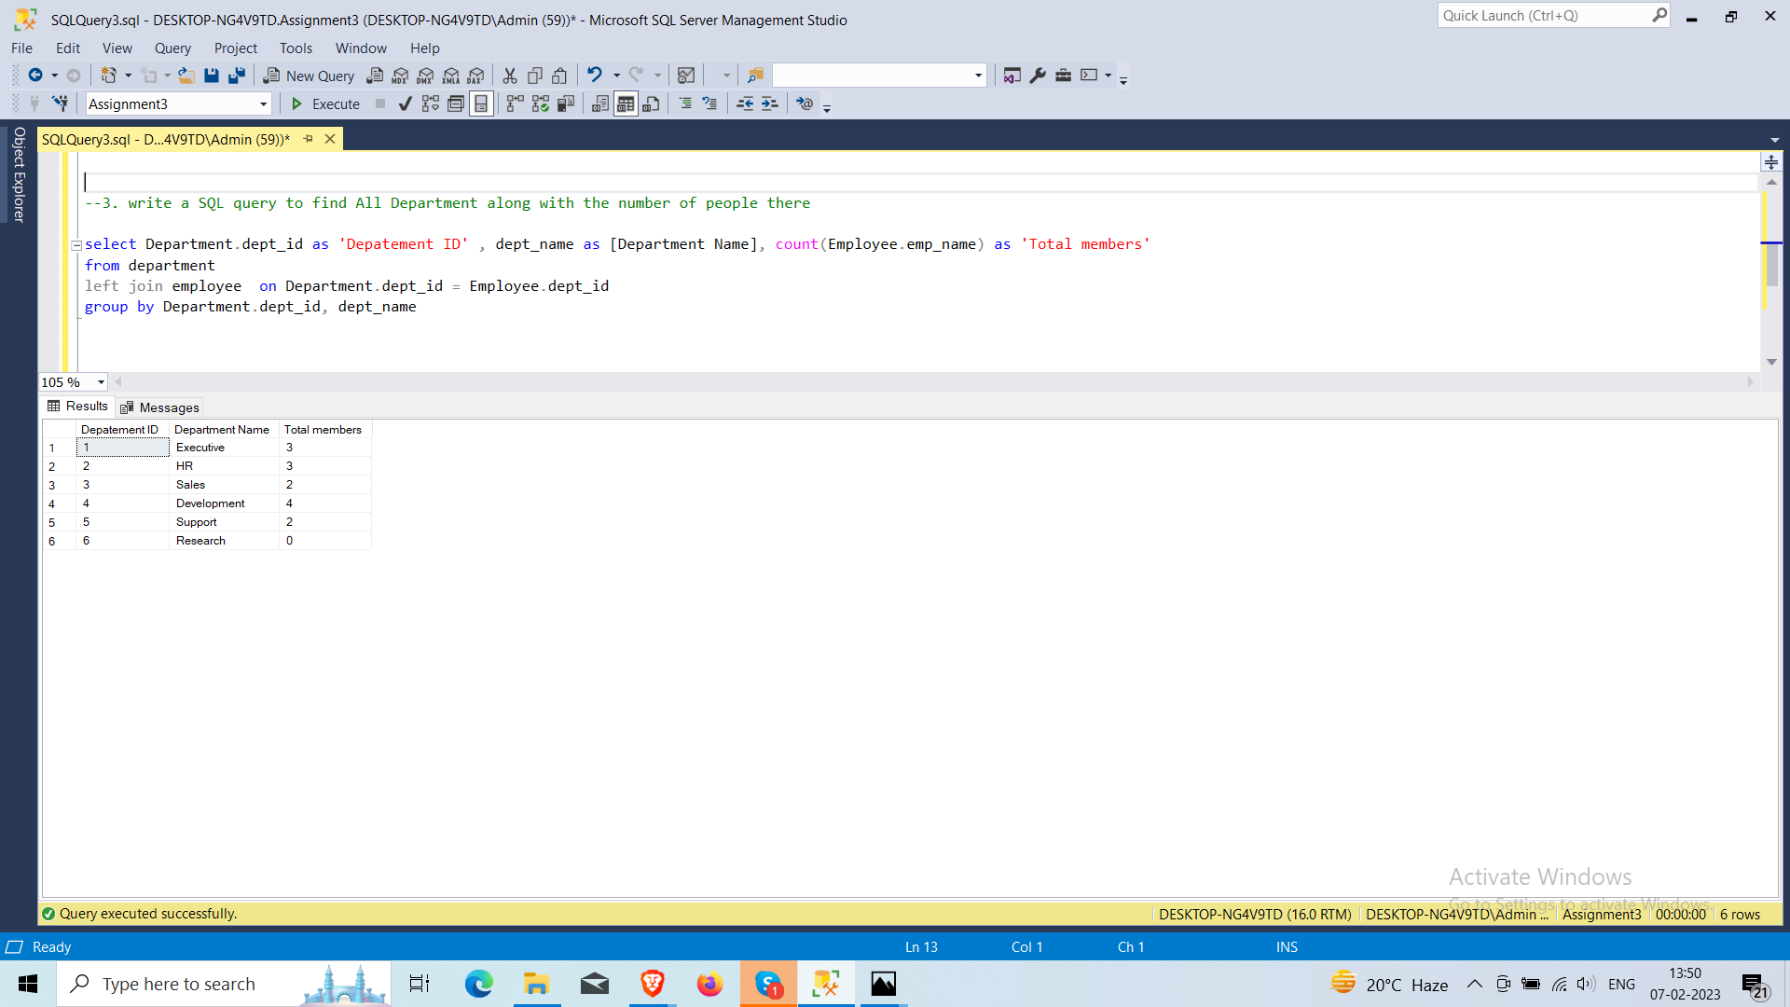

1. **write a SQL query to find All Department along with the total salary there**

select Department.dept_id as 'Department ID', Department.dept_name as DEPARTMENT, sum(salary) as 'Total Salary'

from department

left join employee on Employee.dept_id = Department.dept_id

group by Department.dept_id,Department.dept_name

